NEO4J

Created a new project and added a database

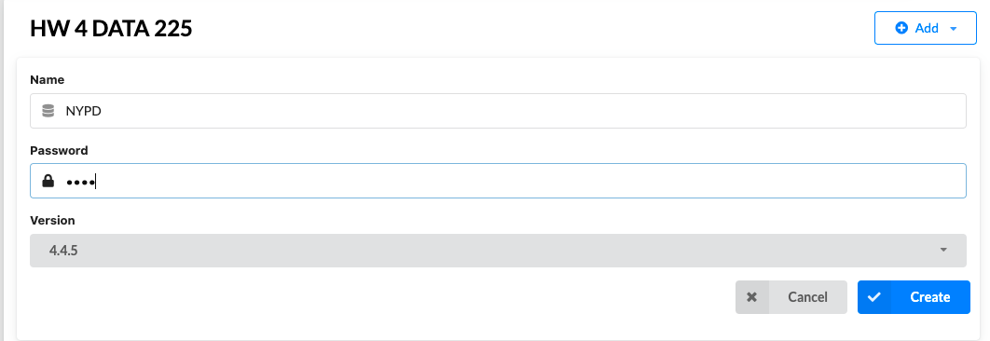

Start the database and import the file

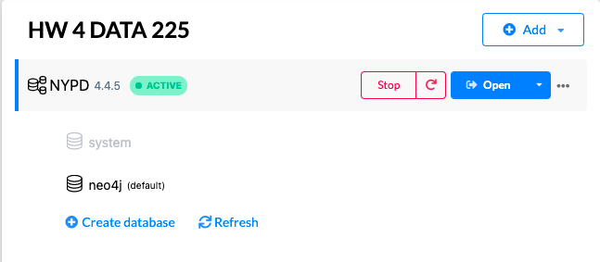

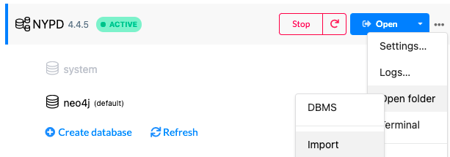

Imported the dataset into the import folder

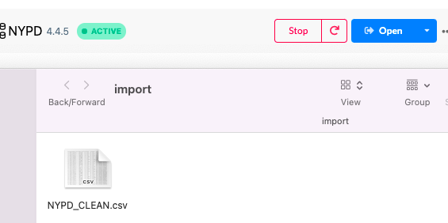

In Neo4j Browser – execute the queries

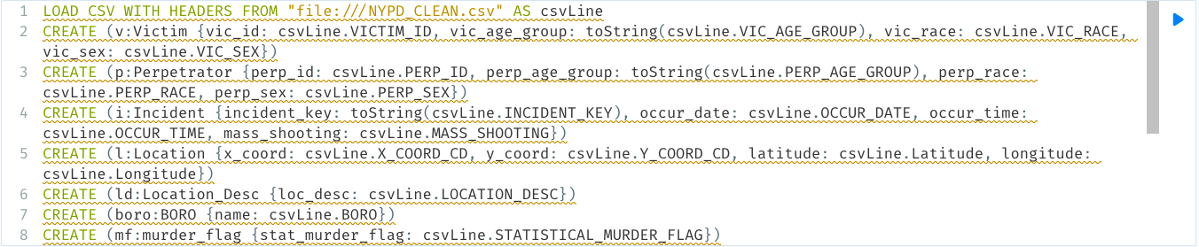

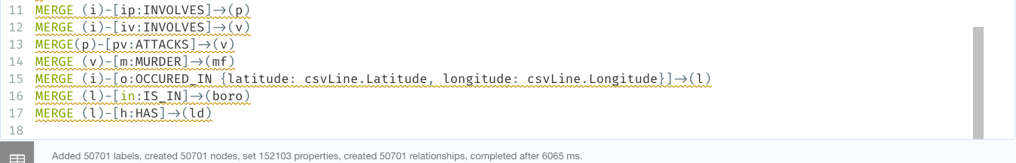

The nodes and the relationships between them

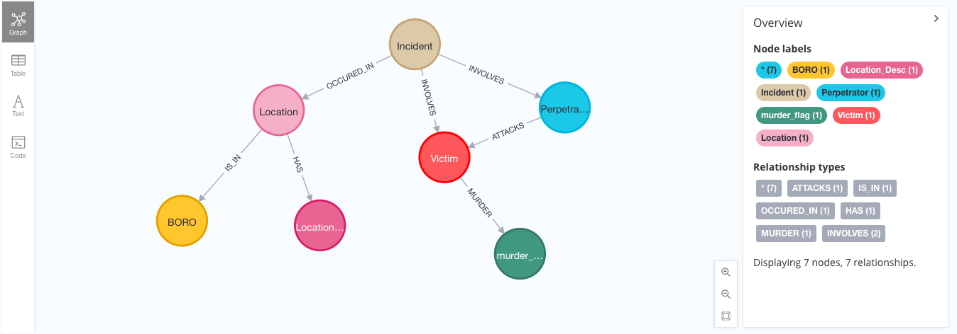

LOAD CSV WITH HEADERS FROM "file:///NYPD_CLEAN.csv" AS row

return row.VIC_AGE_GROUP, count (*) AS AGE_GROUP

order by count (*) desc;

Age groups 25 to 44 were the most attacked in the victim population.

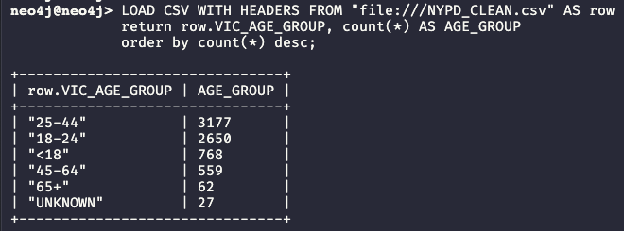

LOAD CSV WITH HEADERS FROM "file:///NYPD_CLEAN.csv" AS row

RETURN row.VIC_SEX, count (*)

ORDER BY count (*) desc;

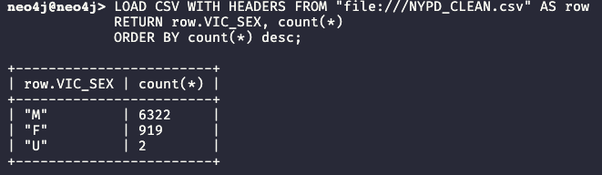

LOAD CSV WITH HEADERS FROM "file:///NYPD_CLEAN.csv" AS row

return row.INCIDENT_KEY as incident_key , count(*) as people_affected, row.LOCATION_DESC as location

order by count(*) desc

LIMIT 20;

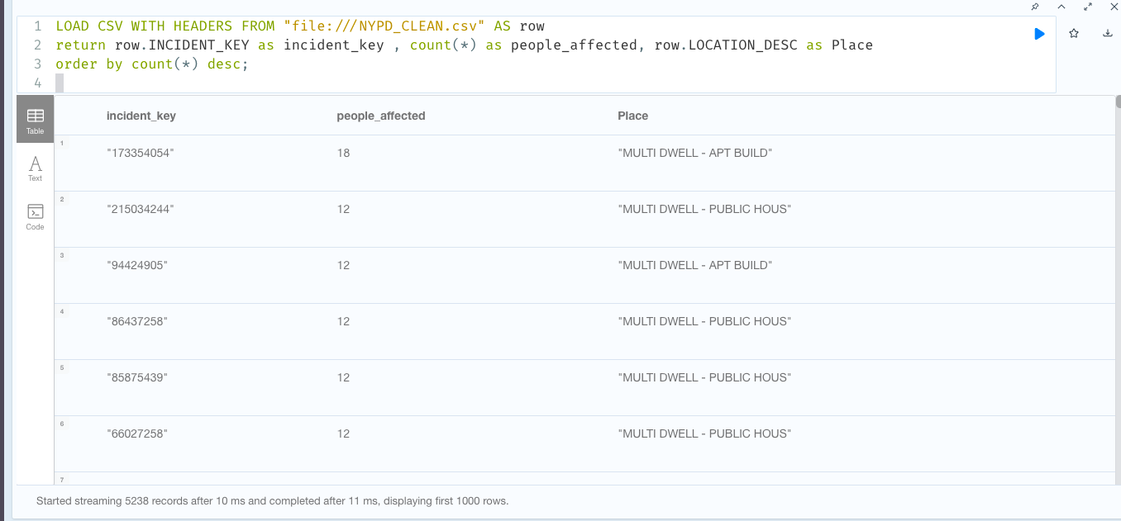

LOAD CSV WITH HEADERS FROM "file:///NYPD.csv" AS row

RETURN row.LOCATION_DESC AS Place, row.VIC_SEX, count(*) AS NUMBER_OF_PEOPLE

ORDER BY row.LOCATION_DESC desc  
LIMIT 20;

